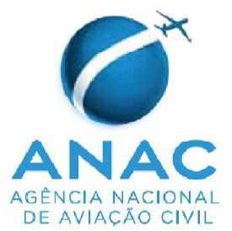 | Superintendência de Padrões Operacionais – SPO  Pre application for the RBAC 145 Maintenance Organization certification in accordance with the Bilateral Agreement between Brazil and United States
Basic Information
To applicant: Information of the 14 CFR part 145 Repair Station:
- Name:
- FAA RS Certificate Number:
- Address:
- E-mail:
- Ratings:
Pre Application:
To FAA and Applicant: The applicant should arrange a meeting with FAA and familiarize themselves with the current editions of the following documents:
- FAA-ANAC Maintenance Implementation Procedures (MIP).
- FAA-ANAC Maintenance Agreement Guidance (MAG).

To FAA and Applicant: A timeframe for the certification process will be stablished and it will be communicated by FAA the certification expectations and requirements.

To FAA and Applicant: After the pre application meeting the applicant has 60 day to proceed or to withdraw the application. Failure to comply with the time frame will render the application null and void

Pre Application Meeting attendants:
.
.
.
.

Date:

Name & Signature of MO Representative:
Name & Signature of FAA PI:

Instructions:
- FAA-ANAC MIP and MAG are available at ANAC website: https://sistemas.anac.gov.br/certificacao/Acordos/Acordos.asp

